Poznań, 4 November 2022

These are the strongest brands in the Polish media.
Read the results of the latest Top Brand report

Press magazine and PSMM Monitoring & More for the 15th time publish the Top Brand report, which includes 50 industry rankings and as many as 500 brands ranked according to brand strength. As we read in the study, this year's jubilee edition is published in a difficult time, because in almost all analyses the theme of the war in Ukraine and the effects it caused is present. As the organisers point out, this situation influences brand communication, but it is also an opportunity for brands to build strong foundations and gather loyal customers around them.

This year's analysis of brand media presence covered as many as 70 million press and online publications (including the social media), which appeared from July 1, 2021 to June 30, 2022. As explained by Izabela Grzechnik, project manager for new research and development at PSMM Monitoring & More: ‘To create industry rankings and a list of the 500 strongest brands in the media, we analysed over 2 million press and 14 million online publications as well as 54 million posts that appeared on publicly available Facebook, Instagram, Twitter and YouTube accounts.’

Research methodology

The key indicator on the basis of which the ranking (comprehensive and industry-specific) is created is brand strength. This multidimensional index consists of values that enable the fullest assessment of the presence of brands in the media, both in terms of the number, reach and sentiment of publications. The most important component of brand strength is impact, i.e. the estimated reach of information about the brand. ‘We calculate it based on data on the reach of a given medium – its circulation in the case of the press, the average monthly number of unique users in the case of websites, or the number of followers on social networking sites,’ Izabela Grzechnik adds.

The second component of brand strength is sentiment. To obtain it, the published content is assessed in terms of its overtone, and then the proportion between the number of positive, negative and neutral mentions is calculated.

Top 10 Brands in Poland

PKO Bank Polski ranked first in this year's edition of the Top Brand competition. Brand strength amounted to 9,125,371 points. The second place was taken by Orlen, with a score of 7,533,505 points. The third brand on the podium was from the energy and raw materials industry - PGE with a score of 6,660,031 points. The fourth position was taken by Onet (6,181,993 points), the fifth – with only 1 point less than in last year's ranking - TVN (6,160,402 points). The sixth place this year - with a decrease by 3 points compared to 2021 - belongs to Bank Pekao (6,139,316 points). Santander Bank moved up to 7th place with a score of 5,986,290 points. Polsat ranked 8th with a score of 5,337,947 points. WP (9th place – 5,257,197 points) and Plus (10th place, 5,138,185 points) also advanced to the top ten of the strongest brands.

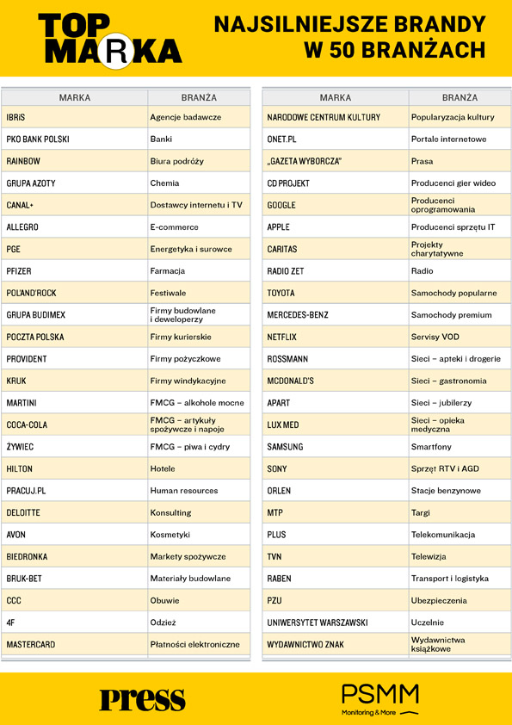

Table 1. The strongest brands in 50 industries – Top Brand 2022

Brands with the best sentiment and impact

One of the aspects analysed in the Top Brand study is the sentiment of the publication. The best result in terms of the sentiment index among the 500 brands included in the report was achieved by Schubert (Networks - Jewellers’) with a score of 4.81. The Almatour brand (Travel agencies) took second place with a score of 4.27. The podium was closed by Capgemini (Consulting) with a score of 4.20.

The highest score in terms of impact, i.e. the number of users reached by coverage, was achieved by publications of Onet (Internet portals) - 9,697,772,631. The second place belongs to WP (Internet portals) - 5,658,831,805, and the third - to TVN (TV stations), which achieved a score of 5,079,254,354.

The Brand of Brands of the 15-year period

On the occasion of the jubilee 15th edition of the Top Brand report, in addition to selecting the 500 strongest media brands, "Press" magazine and PSMM Monitoring & More selected the Brand of Brands of the 15-year period. In this case, all industries researched since the first edition of the report, i.e. since 2008, were taken into account.

The title of the Brand of Brands of the 15-year period was awarded to PKO Bank Polski. The second place was taken by TVN and the podium was closed by Biedronka.

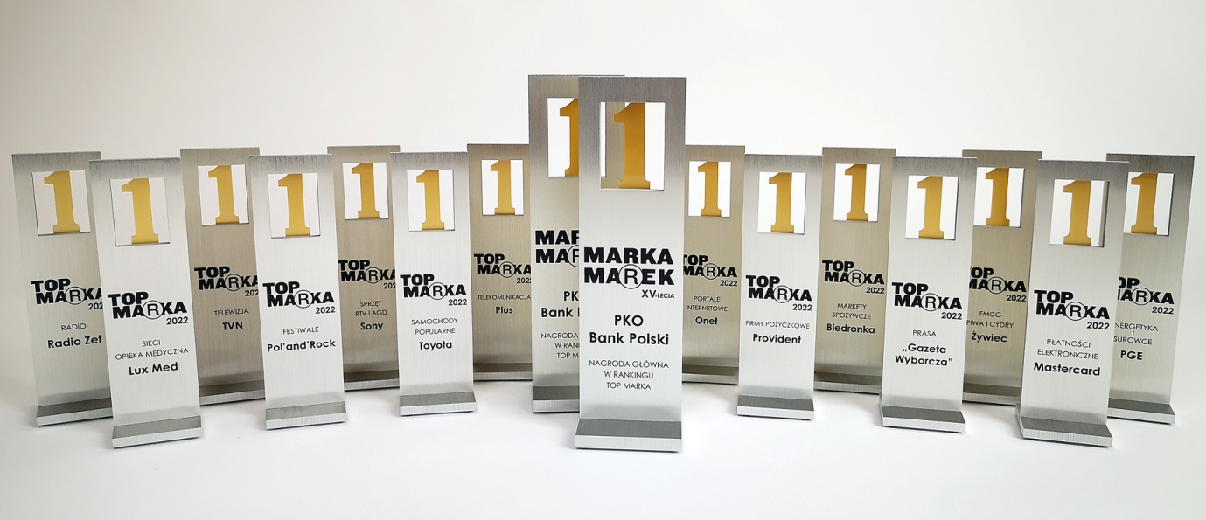

Photo 1. Top Brand 2022 statues

Disinformation is the biggest challenge in brand communication

As every year, the publication of the report was preceded by a debate with representatives of Polish business: Sebastian Bykowski, CEO of PSMM Monitoring & More, Karolina Łuczak, Head of the Press Office and Internal Communications, Spokeswoman for Provident Polska, Łukasz Niewola, Director of Corporate Communications and Sustainable Development of the Lux Med Group, Michał Siegieda, director of corporate communication and PR at Wirtualna Polska Holding, and Paweł Trochimiuk, president of Partner of Promotion. The debate was moderated by Barbara Erling. The theme of this year's meeting was disinformation, which is an increasing challenge for brands.

‘The world is changing before our eyes. It will not be an exaggeration to say that we live in a state of permanent danger. Global changes caused by the pandemic, war, and deepening disinformation mean that brands cannot remain indifferent to these problems,’ comments Sebastian Bykowski, CEO of PSMM Monitoring & More. He adds: ‘Today, brands must stand by specific values. This is expected not only by consumers, but also by the immediate environment – employees and suppliers. Only in this way can we build a competitive advantage.’

The Top Brand industry report - in a basic and extended version - is available on the website: www.topmarka.eu

Methodology in brief
The methodology adopted in the study is based on the use of comparable indicators for all types of mentions, taking into account the specificity of the press, Internet portals and social media. The value determining the position of a brand in the ranking is invariably brand strength - the resultant of several variables (impact, sentiment and the number of publications) showing both the number of contacts of recipients with the brand and the qualitative assessment of the message about it. To calculate the total impact of the analysed materials, the correction factor for short, one-word or one-sentence mentions was used. The impact of such publications on the results of the ranking has been limited so that they do not overshadow the importance of materials related to the current operations of brands and usually have a greater impact on their image.

Indicators used in the ‘Top Brand 2021’ report
Impact – the reach of mention of the brand based on data on the consumption of the medium
Sentiment – overtone-based indicator; it reflects the share of positive, neutral and negative publications in the total coverage on a given brand: the higher, the better
Brand strength – the final value determining the brand’s position in the ranking; it is an index of several variables showing both the number of contacts of recipients with the brand and the qualitative assessment of the message.
Top Brand methodology

Top Brand industry reports – in basic and extended version >> sklep.topmarka.eu

PSMM Monitoring & More and Press sp. z o.o. sp. k. agree to the publication of materials in full or in part, provided that the source is acknowledged (full company name: PSMM Monitoring & More and Press sp. z o.o. sp. k., and social media tagging @PSMMonitoring (FB,TT) and @MagazynPress (FB) and @RedakcjaPress (TT)).

Contact:
Katarzyna Popławska
Head of marketing & PR
mobile: +48 697 410 680
kpoplawska@psmm.pl
PSMM Monitoring & More
60-801 Poznań, ul. Marcelińska 14
www.psmm.pl
www.twitter.com/PSMMonitoring
www.facebook.com/PSMMonitoring

Press editorial team
+48 22 334 83 33
biuro@press.pl
Press sp. z o.o. sp. k.
60-523 Poznań, ul. Dąbrowskiego 75/66
www.press.pl
www.facebook.com/MagazynPress
www.twitter.com/pressredakcja

